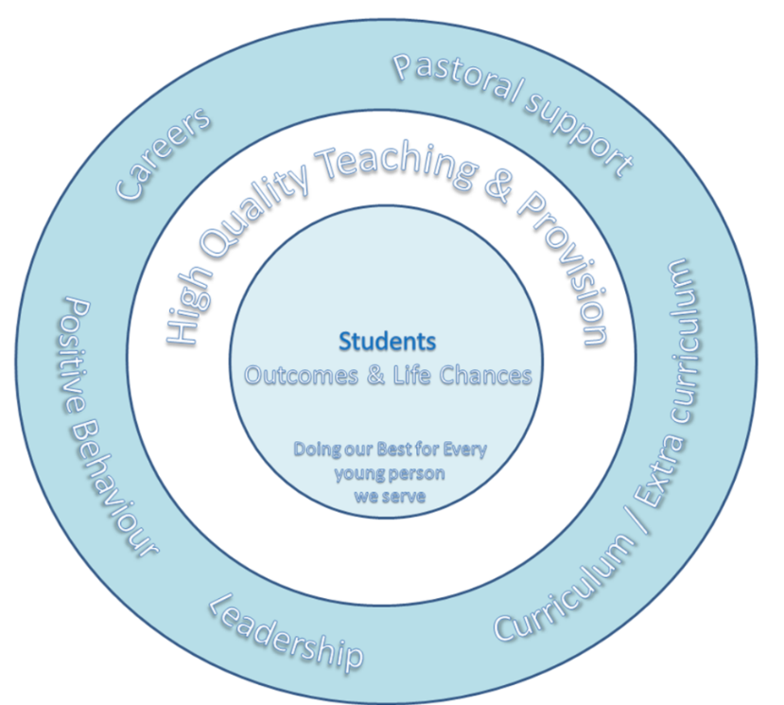

OFSTED November 2016
What does the school need to do to improve further?
- Improve the quality of teaching and raise pupils’ achievements by:
  - Ensuring that all teachers have strong subject knowledge
  - Supporting pupils to reach the more challenging academic targets that have been set.
- Improve pupils’ personal development, behaviour and welfare by:
Raising attendance so that it is at least in line with the national average and reducing persistent absence still further

Ongoing Focus – Maintain and improving financial health in line with FNTI/ Ensure academy building stock is of the highest quality, safe and appropriate/ Deliver CIF Programme at WR,BR

Raise the Quality of Teaching
- Ensure consistently high quality of Teaching & Learning across the Academy, which addresses and responds to the needs of all groups.
- To identify and close gaps in learning particularly with regards to impact of Covid -19 for all groups and adjust curriculum accordingly.
- To ensure quality CPD linked to the school priorities, which demonstrates impact and is shared with all Academy staff.
- To promote and develop resilient, independent learners throughout the Academy. To encourage blended learning as a result of identified strengths of online learning during Covid-19
Improve Pupils’ Personal Development, Welfare & Safety
- Further strengthen pupil participation and culture in all areas of the school, including the House system.
- Ensure that CEIAG is well coordinated across the curriculum in all Key Stages. Equip students with sufficient knowledge and skills to make informed decisions prior to key transitions.
- Provide rapid attendance interventions, targeted focus on persistent absentees with a particular emphasis on pupil premium and SEND students.
- Reduce Fixed Term Exclusions (FTE’s) with a specific focus on students ‘refusal to cooperate’ through restorative processes.
Improve Outcomes for Pupils
- Ensure all pupils make effective progress from their starting points. Ensure all pupils within targeted groups (Disadvantaged, SEND, etc.) needs are met and the progress gap between them and other pupils is closed.
- To implement a Literacy improvement strategy across the curriculum.
- Ensure a relevant and appropriate curriculum is followed by all pupils.
- Develop an appropriate curriculum for SEND students to allow achievement for all.
Improve Leadership & Management
- Ensure that the Academy delivers an in year balanced budget, maintaining excellent financial efficiency.
- Monitor and evaluate the impact of the two sites on key measurements.
- Adopt a whole school approach to tackle emotional well-being and mental health issues for students and staff.
- Quality Assurance of Middle Leaders - working closely with the newly appointed Director of English to secure rapid improvement in this area.
- Implement the new Inclusion strategy to ensure efficiency and impact of all provisions.

Improvement Area: Improve pupils’ personal development, welfare and safety
2.2 Ensure that CEIAG is well coordinated across the curriculum in all Key Stages. Equip students with sufficient knowledge and skills to make informed decisions prior to key transitions.

Intent | Implementation & Monitoring | Impact
- Maintain, further develop & enhance a stable Careers Programme through improved parental interaction. (Gatsby 1.) | - Create & review: Survey for parents/ CEIAG Activity report for parents (C.Atkey/ L.Hay)  - Create & review: Survey for pupils, via Student Council. (C.Atkey/ L.Hay)  - Improve Careers PSHE study programmes (L.Hay/ J.Craw)  - Progression plans drawn up for activities with SDC Create documentation to formulise information sharing process between SDC and Paignton Academy. Review as required. (L.Hay/TLW) | - Improved parental notification of careers provision.  - Increase in parental feedback  - Improvement of quality of pupil feedback  - Adapted study programmes to reflect pupil/ parent responses.  - Enhanced post 16 transition activities
- Address the needs of each pupil. (Gatsby 3.) | - Termly report on carers intervention for potential NEETS. (L.Hay/CSW representative)  - Feedback from SEND staff on training session. (L.HAY/SEND Department) | - Improved guidance referrals for the high-risk NEET pupils.  - Send Staff trained to provide enhanced careers support for SEND pupils.
- Learning from Career & Labour Market Information. (Gatsby 2.) | - PSHE Lessons: pupil feedback regarding activities (L.Hay/PSHE Teachers/ J. Craw)  - Update PSHE lessons and assemblies to include current LMI trends (L.Hay) | - Increased L2L points administered for completed home learning tasks.  - Students have greater understanding of current LMI trends are able to feedback and use to improve own knowledge and understanding- core research skills.

